

CS 305 Project Two

Practices for Secure Software Report

Table of Contents
Document Revision History 3
Client 3
Instructions 3
Developer 4
1. Algorithm Cipher 4
2. Certificate Generation 4
3. Deploy Cipher 4
4. Secure Communications 4
5. Secondary Testing 4
6. Functional Testing 4
7. Summary 4
8. Industry Standard Best Practices 4

Document Revision History

Version | Date | Author | Comments
1.0 | 10/16/2024 | Nate Riggs | Initial Document Creation

Client



Instructions

Submit this completed practice for a secure software report. Replace the bracketed text with the relevant information. You must document your process for writing secure communications and refactoring code that complies with software security testing protocols.

- Respond to the steps outlined below and include your findings.
- Respond using your own words. You may also choose to include images or supporting materials. If you include them, make certain to insert them in all the relevant locations in the document.
- Refer to the Project Two Guidelines and Rubric for more detailed instructions about each section of the template.

Developer
Nate Riggs

Algorithm Cipher

To secure communications at Artemis Financial, I would recommend the use of the Advanced Encryption Standard (AES) and, more specifically, the AES-256 encryption algorithm. AES is a symmetric encryption standard that processes data in 128-bit blocks and supports key lengths of 128, 192, or 256 bits (GeeksforGeeks, 2024). Its efficiency and strong security make it ideal for protecting data confidentiality in applications such as financial transactions, particularly with AES-256, which offers enhanced resistance against brute-force attacks.

In addition to AES, implementing SHA-256 (Secure Hash Algorithm 256-bit) is crucial for ensuring data integrity during transfers. SHA-256 produces a unique 256-bit hash from the input data (Singh, 2024), allowing Artemis Financial to verify that the data has not been altered during transmission. This combination of AES-256 and SHA-256 enhances security by enabling the detection of any modifications to the data.

Random numbers play a vital role in the key generation process for AES as it requires the same key for both encryption and decryption. By utilizing high-quality random number generators, one can ensure that keys are unpredictable and strengthen resistance against potential attacks. Although AES employs symmetric keys, using an asymmetric algorithm for secure key exchange can also provide secure communications.

Adopted by the U.S. National Institute of Standards and Technology (NIST) in 2001 (Dworkin, 2023), AES has become the leading encryption standard, recognized for its robustness and compliance with various regulatory requirements. In summary, implementing AES-256 for encryption alongside SHA-256 for checksum verification creates a comprehensive framework that ensures both confidentiality and integrity in data communications.

Certificate Generation
Insert a screenshot below of the CER file.

Screenshots of key creation and CER file:
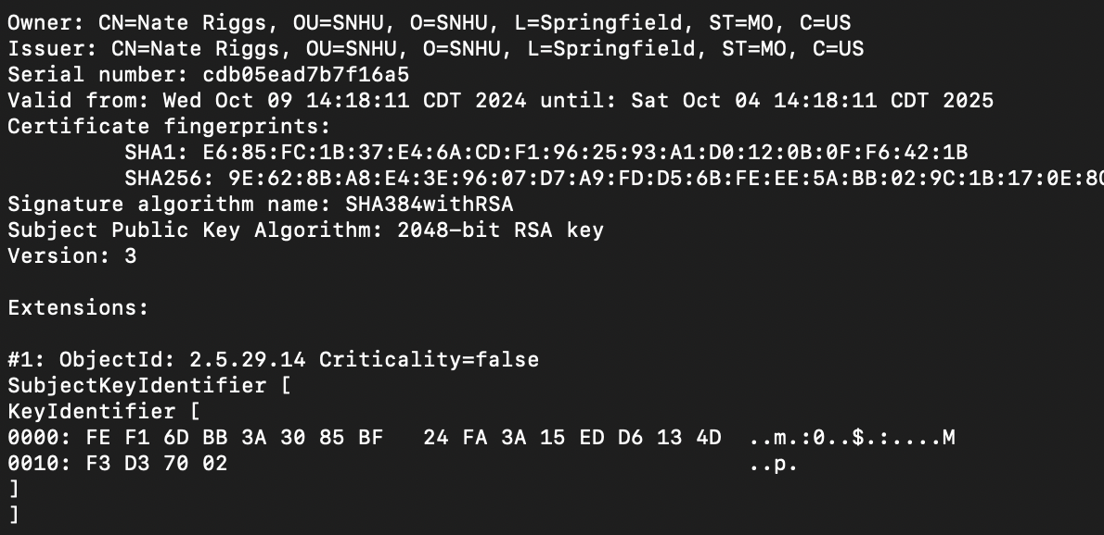
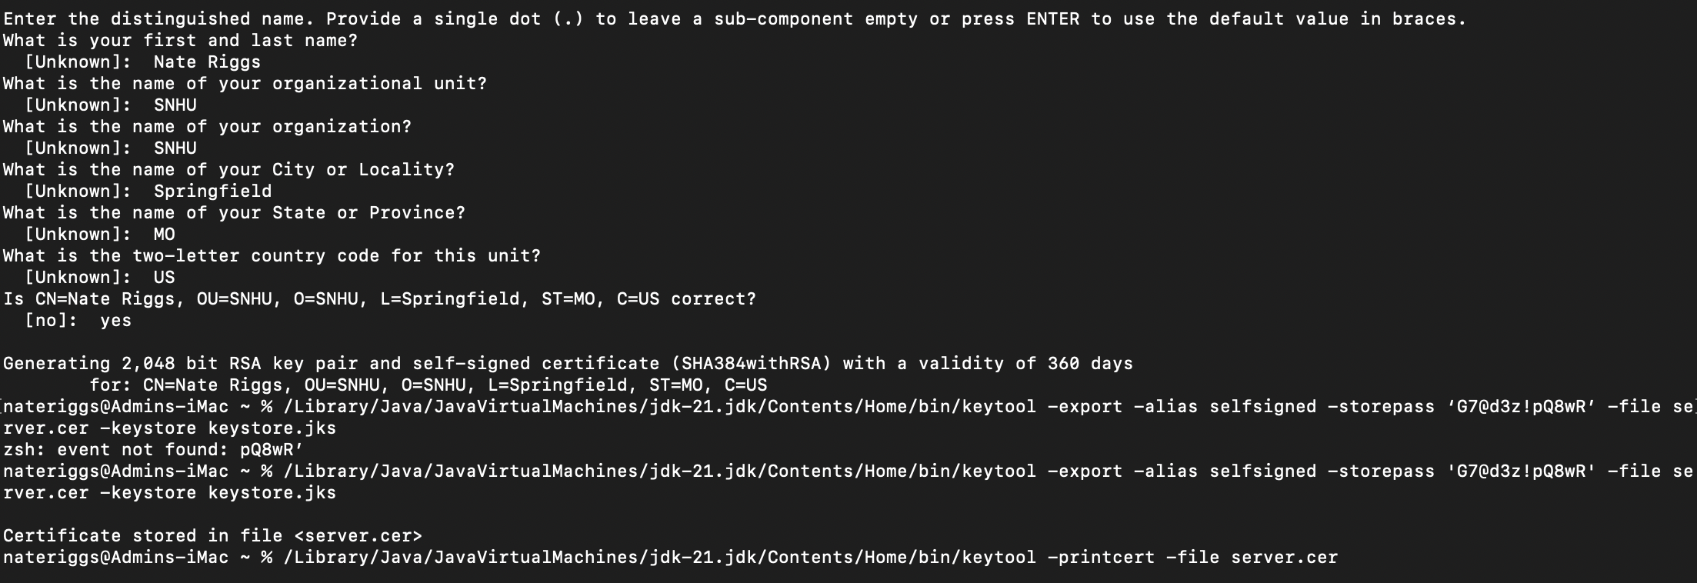
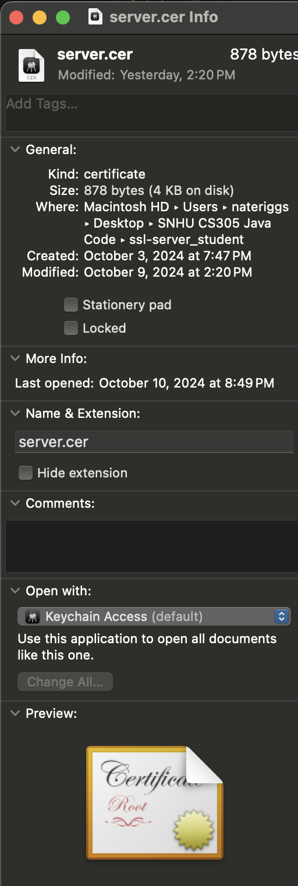

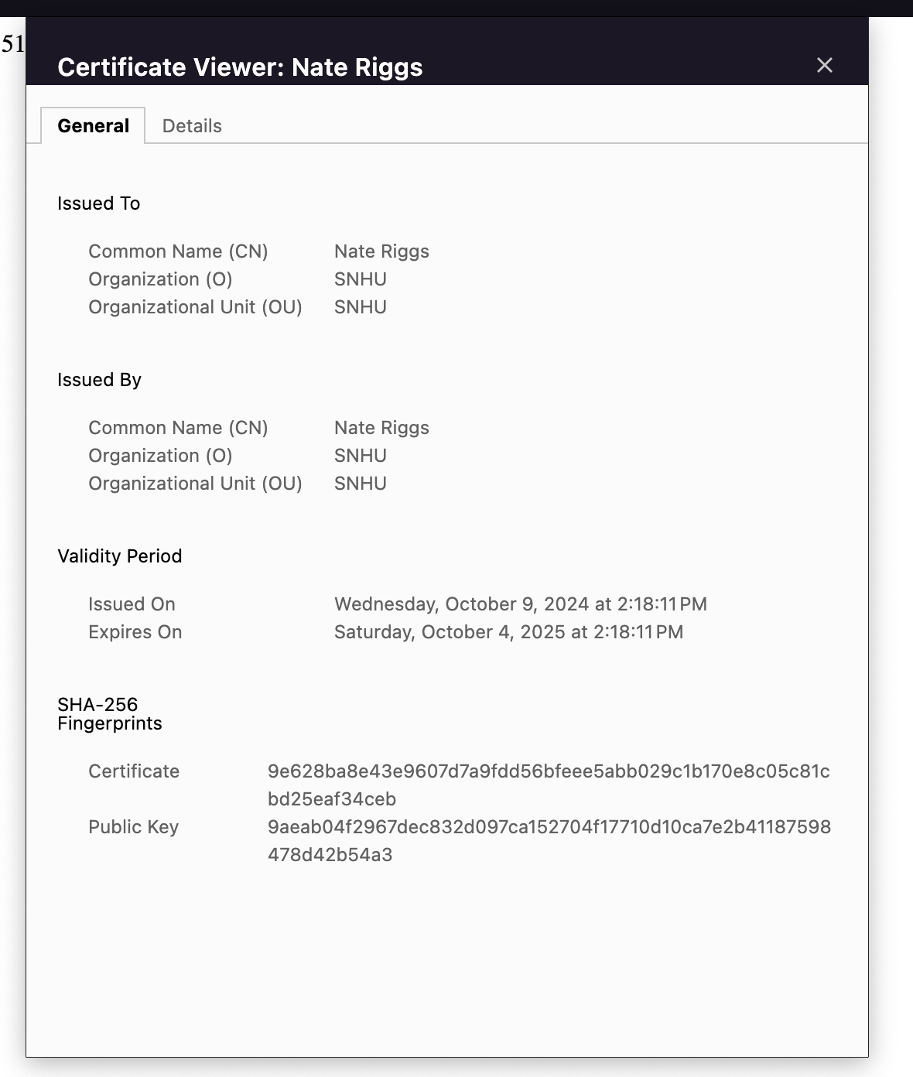

Deploy Cipher
Insert a screenshot below of the checksum verification.

Screenshot of Refactored Code with Checksum Verification: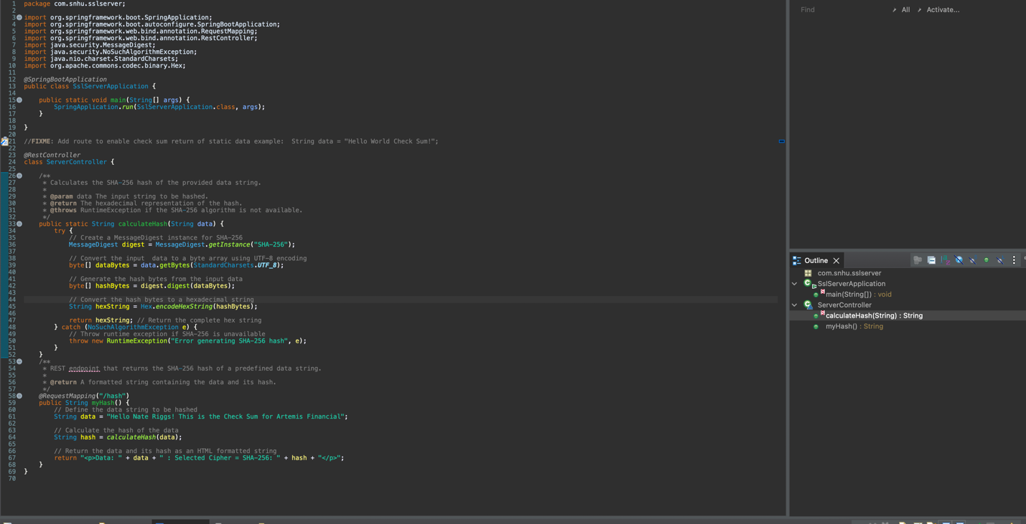
Screenshot of Webpage:

Secure Communications
Insert a screenshot below of the web browser that shows a secure webpage.

Screenshot of Application.properties file:
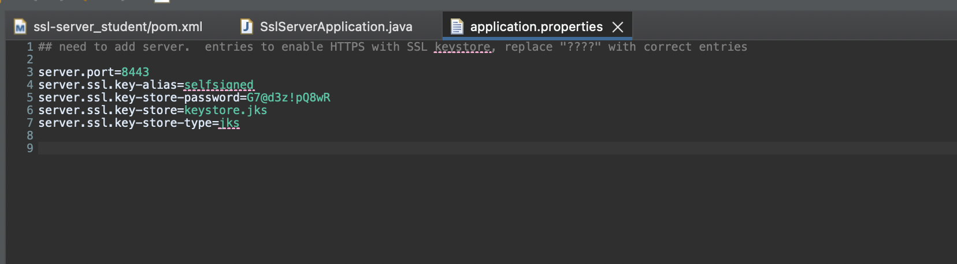

Screenshot of Webpage:

Secondary Testing
Insert screenshots below of the refactored code executed without errors and the dependency-check report.

Screenshot of Refactored code:


Screenshot of Code Execution:
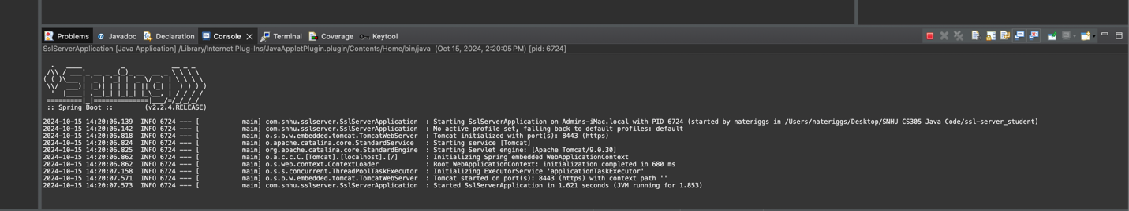
Screenshot of Dependency-Check: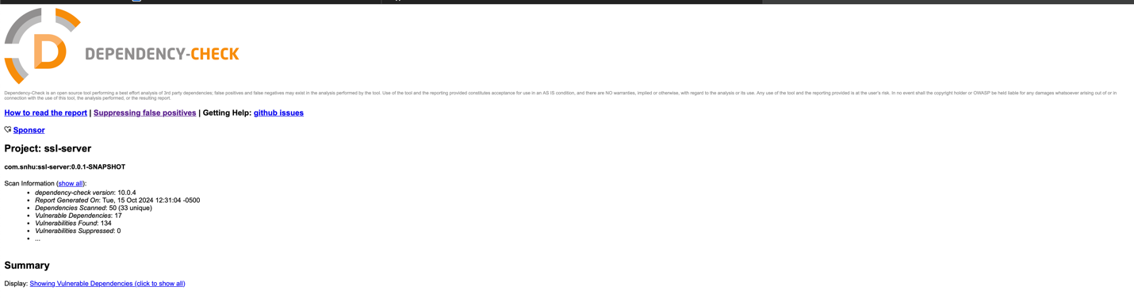

Functional Testing
Insert a screenshot below of the refactored code executed without errors.

Screenshot of Refactored Code Execution without errors:



Summary

The refactored code introduces several key enhancements that strengthen the application’s security and compliance with best practices. By implementing a modular calculateHash method, the code allows for a clear separation of concerns and makes identifying and analyzing potential vulnerabilities easier. The use of the Apache Commons Code for SHA-256 hashing minimizes risks associated with custom implementations, ensuring reliable cryptographic operations. By utilizing the SHA-256 specifically, the risk of collisions is extremely minimal to the size of the hash value. Enhanced error handling in the myHash method prevents sensitive information from being exposed, returning structured error responses instead. This approach not only protects against information leakage but also improves the user experience.

Industry Standard Best Practices

In the refactored code, several industry-standard best practices for secure coding have been applied to effectively mitigate known security vulnerabilities. The modular design, exemplified by the separate calculateHash method, enhances clarity and facilitates independent testing, making it easier to identify potential vulnerabilities. Strong error handling in the myHash method prevents sensitive information from being exposed. By using the established Apache Commons Codec library for SHA-256 hashing, the code avoids the risks associated with custom cryptographic implementations. Clear JavaDoc comments enhance maintainability and facilitate understanding for future developers. Additionally, the code is designed in such a way as to help prepare the application for future attacks by implementing input validation. The value of applying these best practices extends beyond immediate security; it significantly reduces risk, lowers costs associated with potential breaches, ensures compliance with regulations, enhances the company's reputation, and fosters sustainable development practices. By prioritizing secure coding, the organization not only protects sensitive information but also reinforces customer trust and positions itself competitively in the market.

Reference List

GeeksforGeeks. (2024, July 16). Advanced Encryption Standard (AES). GeeksforGeeks. https://www.geeksforgeeks.org/advanced-encryption-standard-aes/

Singh, P. (2024, July 15). What is SHA-256? | Encryption Consulting. Encryption Consulting. https://www.encryptionconsulting.com/education-center/sha-256/

Dworkin, M. J. (2023). Advanced Encryption Standard (AES). https://doi.org/10.6028/nist.fips.197-upd1

